**Experiment 2**

Design an LED Chaser

**Circuit Diagram**

**Theory:**

**Concept Used:**

The concepts used for realization and implementation of the task are:

* The arduino board supply a power of 5V which we call as HIGH and 0V which we call as LOW digital output signals through the 14 pins present on the Arduino board

* The GND pin on Arduino board is ground.
* And the concept of breadboard where there are two rows each on top and bottom of it, connected to each other.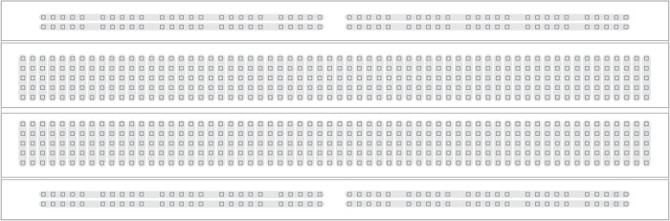
* We were told that in series, voltage gets divided and in parallel the current gets divided.

**Learning and Observation:**

**Learning:**

* With the help of this connection I learnt about connections in parallel using Arduino board and breadboard.
* I also got to know different LEDs pattern glowing using Arduino signals and coding on the software.

**Observations:**

* While performing when the code was uploaded I observed that initially two LEDs were glowing and then first went off and then third one glows and a sort of pattern is followed.

**Problems and Troubleshooting:**

* The circuit was not getting closed because some wires used were short and not at place so I tried to change the position.
* The Arduino board was not working because of short wire and port being far from where the hardware was kept so had to change some positions in order to get it worked.
* I had some issues with code initially so had to change my coding many times and I also forgot to choose port and tools option.

**Precautions:**

The precautions that we need to keep in mind while performing this experiment are

* The wires and the LED used should be inserted properly in the breadboard for the hardware to work properly
* The pins of the LED should be connected properly. The ‘p’ and ‘n’ side of the LED should be checked.
* We should take care that the circuit is closed .

**Learning Outcomes:**

* I have gained about certain projects and circuits using Arduino board and breadboard.
* I have got to know about glowing LEDs by running codes on Arduino software and various other connections.